**

**JamesThewDOTcom**

|  |  |  |
| --- | --- | --- |
| **Supervisor:** | *LE THANH NHAN* | |
| **Semester:** | *III* | |
| **Batch No:** | *T1.2208.M2* | |
| **Group No:** | *3* | |
| **Order:** | **Full name** | **Roll No.** |
| *1.* | *Bui Tran Anh Tri* | *Student1414230* |
| *2.* | *Pham Tien Duc* | *Student1414248* |
| *3.* | *Hoang Ngoc Phu* | *Student1396925* |
| *4.* | *Nguyen Hoang Trung* | *Student1414357* |

***December 2023***

** This is to certify that

|  |  |
| --- | --- |
| **Mr.** | **Bui Tran Anh Tri** |
| **Mr.** | **Pham Tien Duc** |
| **Mr.** | **Hoang Ngoc Phu** |
| **Mr.** | **Nguyen Hoang Trung** |

Have successfully Designed & Developed

|  |  |  |
| --- | --- | --- |
|  |  |  |
| **JamesThewDOTcom** | | |

Submitted by:

|  |
| --- |
| **MR. LE THANH NHAN** |

Date Of Issue:

|  |  |
| --- | --- |
|  |  |

Authorized Signature:

* Table of Contents

REVIEW 1 6

I. Acknowledgement 7

II. Synopsis 8

III. Problem Definition 9

IV. Customer Requirements Specifications 10

1. Introduction: 10

2. Input to the system: 10

a. User Registration Data: 10

b. Recipe and Tip Submissions: 10

c. Feedback and Contest Participation: 10

3. Process Involved in the System: 10

a. User Authentication and Profile Management: 10

b. Content Management and Access Control: 10

c. Contest and Feedback Management: 10

4. Output from the system: 11

a. Personalized User Experiences: 11

b. Recipe and Content Display: 11

c. Interactive Features: 11

d. FAQ and Support: 11

V. Functional Requirements Specifications 12

1. User Functions: 12

a. Un-Registered Users: 12

b. Registered Users: 12

2. Admin Functions: 12

VI. Non-Functional Requirement Specifications: 12

VII. System requirement specifications (2023) 12

1. Server Requirements 13

2. Software: 13

3. Client Requirement: 14

4. Software: 14

5. Development Software 14

6. Technology 14

TASK SHEET REVIEW 1 15

REVIEW 2 16

I. Architecture and Design of the Project: 17

II. Data Flow Diagram (DFD) 18

1. Definition of Data Flow Diagram (DFD): 18

2. Four Main Activities Supported by DFD: 18

a. Analysis: 18

b. Design: 18

c. Communication: 18

d. Documentation: 19

e. External Entities in DFD: 19

f. The Process in DFD: 19

g. Data Flow in DFD: 20

h. Data Store in DFD: 20

3. Context Level Diagram (Level 0) 21

4. Level 1 DFD 22

III. Entity Relationship Diagram (ERD) 23

IV. Table Design 24

1. User Management: 24

2. Recipes & Tips Management: 25

V. Relationship Diagram 30

VI. Sitemap 31

1. General User 31

2. User 32

3. Admin 33

VII. Algorithm 34

1. Displays the flowchart for the Home page 35

2. Displays the flowchart for the Recipes/ Tips activity 36

3. Displays the flowchart for the Book activity 37

4. Displays the flowchart for the Contest activity 38

5. Displays the flowchart for the Admin activity 39

REVIEW 1

# Acknowledgement

As the team leader, Bui Tran Anh Tri, I would like to extend my heartfelt gratitude to everyone who contributed to the development of our eProject. This endeavor has been a journey of learning, innovation, and collaborative effort. Our sincere thanks go to the mentors and educators at Aptech for their unwavering support and guidance. Their expertise and dedication have been pivotal in shaping this project and our understanding.

We are also immensely grateful to our team members, Mr Duc, Mr Trung, Mr Phu, whose commitment, creativity, and hard work have turned our ideas into a tangible reality. Their willingness to embrace new challenges and adapt to rapid changes in technology has been inspiring.

A special mention to Mr Sinh, Mr Nhan, those who participated in the brainstorming sessions, provided critical feedback, and assisted in refining our concepts. Your contributions have been invaluable in enhancing the quality and scope of our project.

Lastly, our appreciation extends to our peers and the IT community for their encouragement and insights. This project not only represents our technical skills but also our collective effort to keep pace with the evolving world of IT education.

Thank you all for being a part of this rewarding journey. Together, we have created something truly remarkable.

# Synopsis

Our project is designed to bridge the gap between theoretical learning and practical application. We focus on providing a real-life scenario for students to develop basic applications using the tools and knowledge they have acquired. This hands-on approach, conducted in lab sessions with faculty assistance, is aimed at enhancing understanding and skill in application development. The project is not about teaching software, but about applying concepts to build robust applications in real-world settings. Students are encouraged to clarify doubts with the eProjects Team to deepen their understanding and successfully achieve the project objectives.

# Problem Definition

In the bustling world of culinary arts, James Thew stands out not only as a renowned chef but also as a pioneer of culinary innovation and community engagement. While his professional life thrives in a five-star hotel environment and his passion extends to teaching and sharing recipes, James envisages a new venture: organizing online cooking competitions. These competitions are designed to stir up the culinary community, inviting enthusiasts and aspiring chefs to showcase their skills and creativity.

The challenge is to create a digital platform that caters to the unique dynamics of these culinary contests:

For Participants (Users/Members): A user-friendly interface for participants to register, submit their unique recipes, and track their submissions. The platform should allow users to upload their recipe details, preparation methods, and images or videos of their dishes. It will enable a vibrant exchange of culinary ideas and foster a sense of community among participants.

For James Thew (Judge/Administrator): A streamlined system for James to review, evaluate, and select the most exceptional and timely submitted recipes. The platform needs to equip James with tools for efficient management of contest entries, judging criteria, and timely announcement of winners.

For Webmaster/Administrator: A robust back-end infrastructure to manage user registrations, recipe submissions, contest timelines, and communications. The platform should offer analytics and reporting tools to track participation, engagement, and feedback, which are crucial for the continuous improvement of these culinary competitions.

# Customer Requirements Specifications

## Introduction:

This document presents a comprehensive outline of the Customer Requirements Specifications (CRS) for the development of a culinary website envisioned by Mr. James Thew. The website aims to offer a unique platform for food enthusiasts across the globe to access, participate, and engage with various cooking recipes and contests.

## Input to the system:

### User Registration Data:

- New users input personal details for registration, choosing between monthly ($10) and yearly ($100) subscription models.

- Non-registered users have limited access and can input data for contest participation.

### Recipe and Tip Submissions:

- Users, including Mr. James, can input recipes and cooking tips, with ingredients and procedures.

### Feedback and Contest Participation:

- Users provide feedback on recipes and participate in contests by submitting their own recipes and tips.

## Process Involved in the System:

### User Authentication and Profile Management:

- Secure login processes for different user roles (Admin/Mr. James, Registered Users, Visitors).

- Profile editing and management capabilities for users.

### Content Management and Access Control:

- Mr. James can manage, upload, and categorize recipes and tips (free or member-exclusive).

- Implementing search functionalities for easy navigation of recipes and tips.

### Contest and Feedback Management:

- Mechanism for Mr. James to organize, manage, and announce contest winners.

- System to gather, display, and manage user feedback on recipes.

## Output from the system:

### Personalized User Experiences:

- Tailored home pages and content access based on user roles and subscription status.

- User profiles reflecting personal data and activity history.

### Recipe and Content Display:

- Publicly available recipes and exclusive content for members.

- Contest entries and winner announcements.

### Interactive Features:

- User feedback displayed on recipe pages.

- Notifications and updates on contests, new recipes, and tips.

### FAQ and Support:

- A comprehensive FAQ section addressing common queries and instructions.

- Support mechanism for user inquiries and assistance.

**Conclusion:**

This CRS aims to encapsulate the essence of Mr. James's vision for a dynamic and engaging culinary website. Through careful consideration of the IPO model, this website is designed to offer an intuitive and enriching experience for all categories of food enthusiasts, ensuring robust functionality, user engagement, and seamless content management.

# Functional Requirements Specifications

## User Functions:

### Un-Registered Users:

REQ-01. Register with provided details after making a payment.

REQ-02. Limited access to various recipes and cooking tips.

REQ-03. Participate in contests by submitting their own recipes and tips.

### Registered Users:

REQ-04. Access all functions available to Un-Registered users.

REQ-05. Log in and log out of the website.

REQ-06. Access to all exclusive recipes and cooking tips.

REQ-07. Profile: Users can change their password, view and edit payment details, view contest participation and feedback history.

## Admin Functions:

REQ-08. Log in, log out, change password.

REQ-09. Manage, upload, and categorize recipes and cooking tips.

REQ-10. View and manage contest entries.

REQ-11. View, change password, and delete user accounts.

REQ-12. View and delete user feedback.

REQ-13. Manage categories and recipe classifications.

# Non-Functional Requirement Specifications:

REQ-14. User-friendly User Interface (UI) and User Experience (UX).

REQ-15. Clean, maintainable, and scalable code.

REQ-16. Enhanced performance of the website.

REQ-17. Compatibility with all modern browsers.

REQ-18. Responsive design for mobile, tablet, and desktop devices.

REQ-19. Minimize bugs and errors on the website.

# System requirement specifications (2023)

## Server Requirements

| **Component** | **Minimum Requirement** | **Recommended Requirement** |
| --- | --- | --- |
| **CPU** | Processor type: Intel Core i3 or equivalent | Processor type: Intel Core i5 or equivalent |
| **Processor Speed** | 2.0 GHz or faster | 3.0 GHz or faster |
| **OS** | Microsoft Windows 10 or higher with IIS | Microsoft Windows 10 or higher with IIS |
| **Memory (RAM)** | 4 GB | 8 GB or more |
| **Hard Drive** | Free space: 100 GB | Free space: 200 GB or more |

## Software:

| **Component** | **Requirement** |
| --- | --- |
| **ASP.NET Core** | Version .NET Core 6.0 or later |
| **RDBMS** | SQL Server 2019 or later |

## Client Requirement:

| **Component** | **Minimum Requirement** | **Recommended Requirement** |
| --- | --- | --- |
| **CPU** | Processor type: Intel Core i3 or equivalent | Processor type: Intel Core i5 or equivalent |
| **Processor Speed** | 1.5 GHz or faster | 2.5 GHz or faster |
| **OS** | Windows 10, Linux, Android, macOS | Latest version of OS |

|  |  |  |
| --- | --- | --- |
| **Memory (RAM)** | 2 GB | 4 GB or more |
| **Hard Drive** | Free space: 50 MB | Free space: 100 MB or more |

## Software:

| **Component** | **Requirement** |
| --- | --- |
| **Web Browser** | Latest versions of Chrome, Firefox, Edge, Safari |

## Development Software

* SQL Server 2019 or later.
* Microsoft Visual Studio 2022 or later.

## Technology

* ASP.NET Core 6.0 or later.
* Entity Framework Core 6.0 or later.

# 

# TASK SHEET REVIEW 1

|  |  |  |  |  |  |  |
| --- | --- | --- | --- | --- | --- | --- |
| **Project Ref. No.:**  **eP/Advertisement** **Portal Management** **System/01** | | **Activity Plan** **Prepared** **By:** | **Date of Preparation of Activity Plan:** | | | |
| **St.No.** | **Task** | **Actual Start** **Date** | **Actual** **Days** | **Team** **Mate** **Names** | **Status** |
| 1 | Acknowledgement  Problem Definition  Requirement Specification  Task sheet review  Contest Page Management (Admin Dashboard - Backend) | Bui Tran Anh Tri | 11/12/2023 | 3 | Bui Tran Anh Tri | Completed |
| 2 | Book Page Management (Admin Dashboard - Backend) | 11/12/2023 | 3 | Nguyen Hoang Trung | Completed |
| 3 | Recipe Page Management (Admin Dashboard - Backend) | 11/12/2023 | 3 | Pham Tien Duc | Completed |
| 4 | User Page Management (Admin Dashboard - Backend) | 11/12/2023 | 3 | Hoang Ngoc Phu | Completed |

REVIEW 2

# Architecture and Design of the Project:

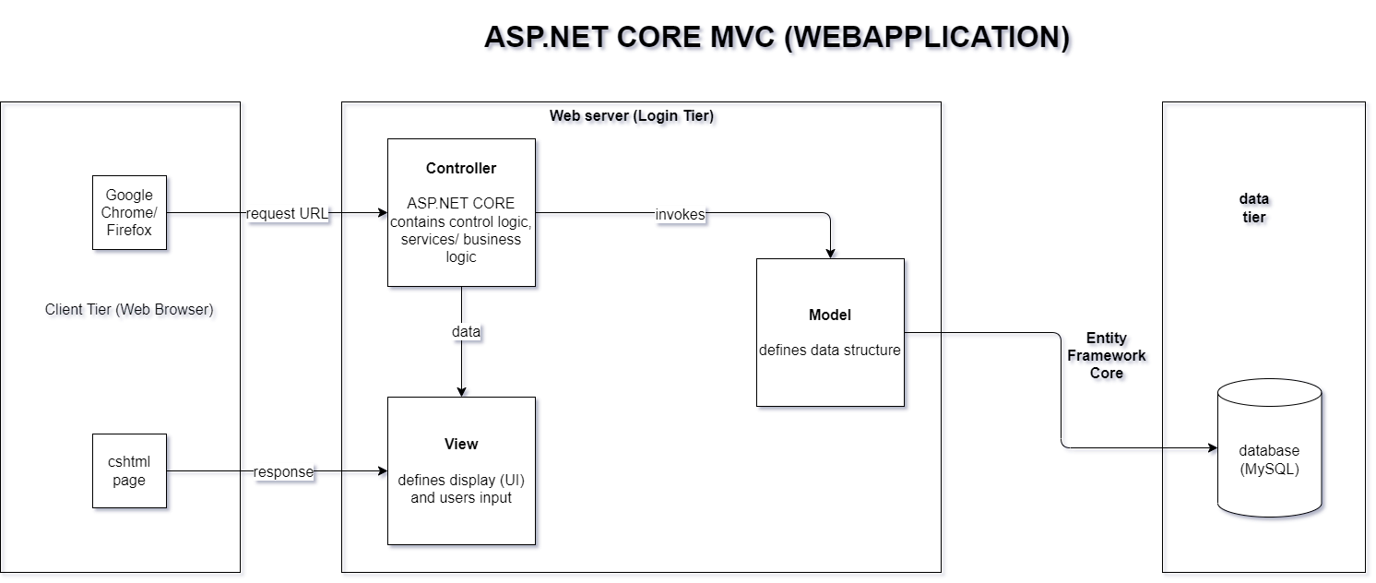

Figure 1: Architecture and Design of the Project

# Data Flow Diagram (DFD)

## Definition of Data Flow Diagram (DFD):

A Data Flow Diagram (DFD) is a graphical representation that depicts the flow of data within a system. It serves as a critical tool in systems analysis, helping to identify and illustrate the movement of information between different components of a system. DFDs are instrumental in understanding, documenting, and communicating the processes and data involved in system functionalities.

## Four Main Activities Supported by DFD:

### Analysis:

In the realm of system development, a DFD is a vital tool for determining user requirements. It helps in analysing the processes and identifying the flow of information, which is crucial for understanding the needs and constraints of the system. By visualizing how data moves through the system, analysts can pinpoint areas for improvement and optimization.

### Design:

DFDs are extensively used in the design phase of system development. They provide a clear and concise way to map out and illustrate the proposed solutions to the requirements identified in the analysis phase. By offering a visual representation of data flows and how they interact with various system components, DFDs assist designers in conceptualizing and creating efficient and effective system architectures.

### Communication:

One of the key strengths of DFDs lies in their simplicity and ease of understanding. They act as a common language between analysts, designers, and users, facilitating clear and effective communication regarding system processes and data flows. This

transparency is essential for ensuring that all stakeholders have a mutual understanding of the system's design and functionality.

### Documentation:

DFDs serve as an essential part of system documentation, providing a detailed depiction of system requirements and design. They offer an overview of the key functional components of a system without delving into the intricate details of each component. For more detailed information, supplementary tools such as database dictionaries and process specifications are used in conjunction with DFDs to provide a comprehensive understanding of the information exchanges and operational procedures within the system.

### External Entities in DFD:

C:\Users\Admin\Downloads\1.pngExternal entities in a Data Flow Diagram represent outside factors that interact with the system. These can be individuals, groups, or organizations that either supply information to the system or receive output from it. External entities are crucial in understanding the system's boundaries and the interactions it has with the external environment. They are typically depicted as rectangles or ovals in a DFD and are the sources and destinations of data flows, highlighting the system's reliance on and relationship with external actors.

### The Process in DFD:

Processes in a DFD symbolize the operations or activities that occur within the system. These are depicted as circles or rounded rectangles and are where data is processed or transformed. Each process in a DFD has a unique number or identifier and a descriptive title. They represent the logical functions or steps in which the incoming data is handled, manipulated, or utilized to produce a specific output. Processes are central to understanding the internal workings of the system and how data is used to achieve the desired outcomes.

### Data Flow in DFD:

C:\Users\Admin\Downloads\3.pngData flow in a DFD illustrates the route that data takes from one part of the system to another. Represented by arrows, these flows show the movement of data between external entities, processes, and data stores. The direction of the arrow indicates the direction of the data movement. Data flows are labeled to describe the type of data or information that is being transferred. Understanding data flows is essential for identifying how information is communicated and shared within the system, ensuring the integrity and efficiency of data handling.

### Data Store in DFD:

C:\Users\Admin\Downloads\4.pngA Data Store in a DFD represents a storage area where data is held for future use. It is depicted as two parallel lines with a descriptive label identifying the store. Data Stores are used to model collections of data that are at rest, such as databases or repositories. They are connected to processes through data flows, signifying the input and output of data to and from these storage areas. Data Stores are integral to understanding how and where data is retained within the system, providing insights into the system’s data management and retention strategies.

## Context Level Diagram (Level 0)

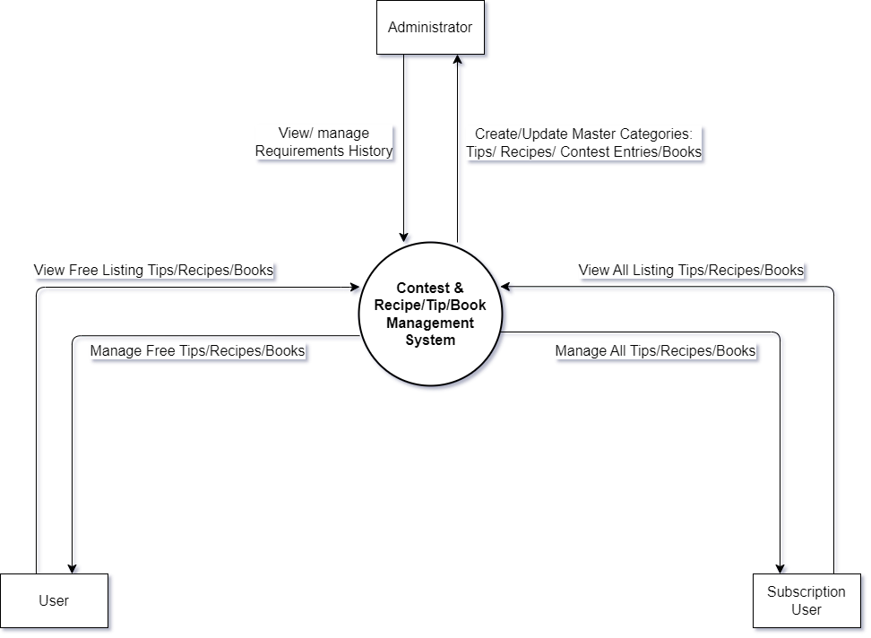

Diagram 1: Context Level

## Level 1 DFD

Diagram 2: Level 1

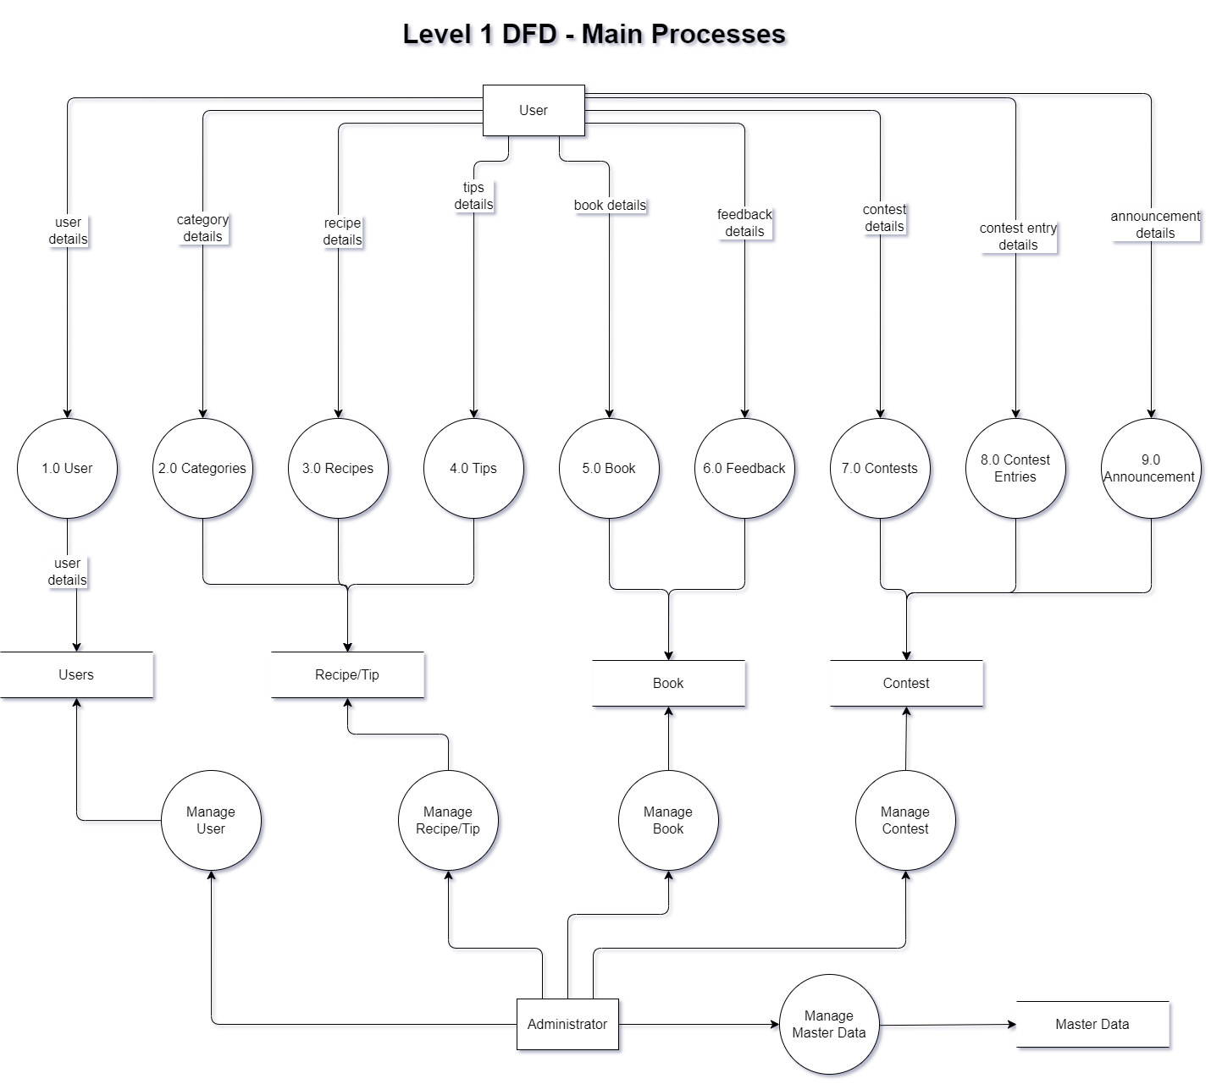

# Entity Relationship Diagram (ERD)

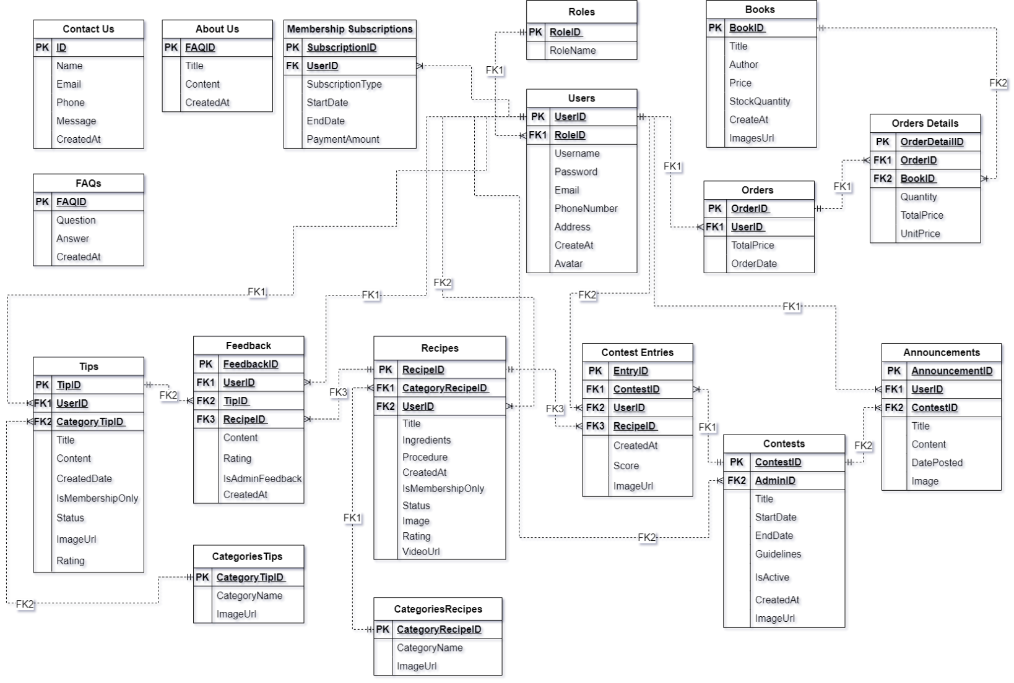

# Table Design

## User Management:

## Recipes & Tips Management:

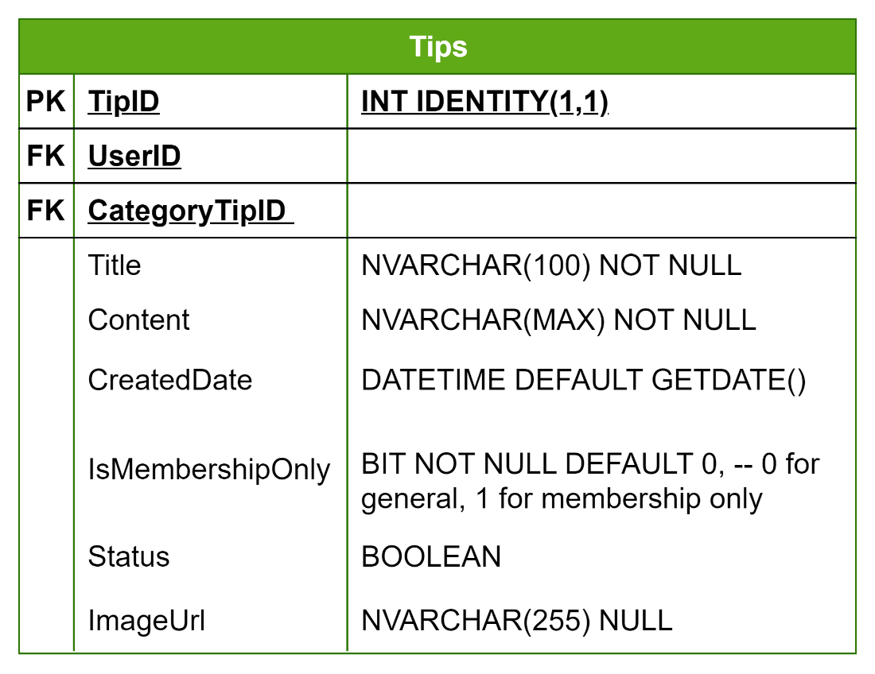

**Contests Management:**

**Book Management:**

# Relationship Diagram

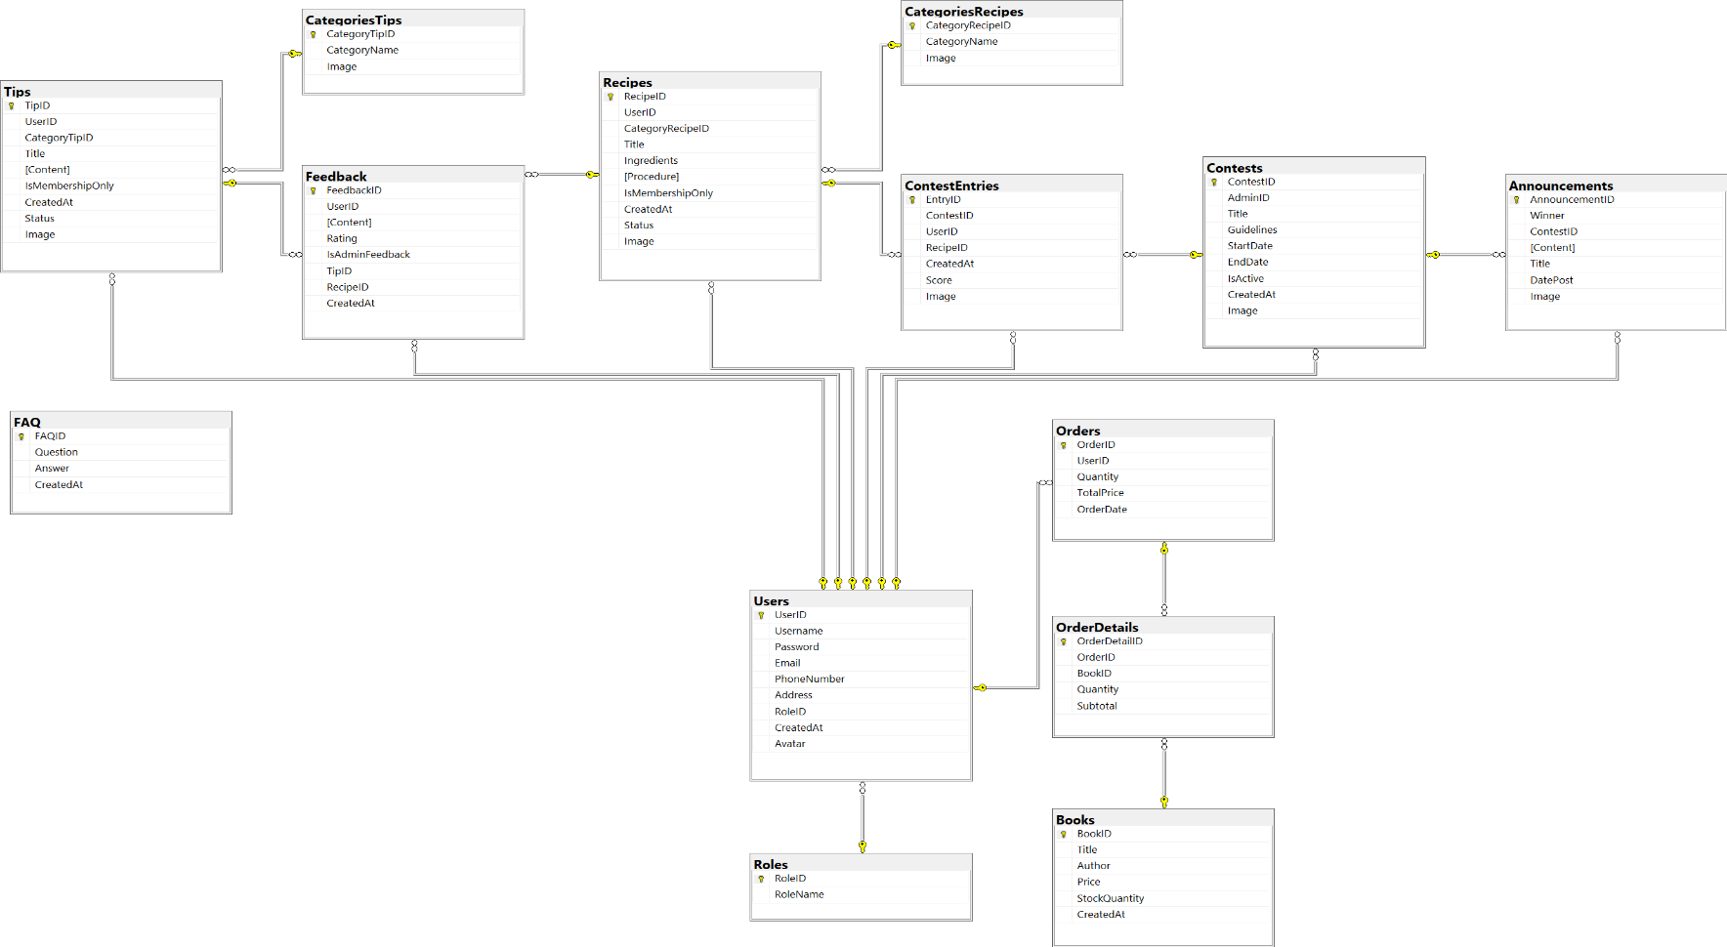

# Sitemap

## General User

## User

## Admin

# Algorithm

## Displays the flowchart for the Home page

## Displays the flowchart for the Recipes/ Tips activity

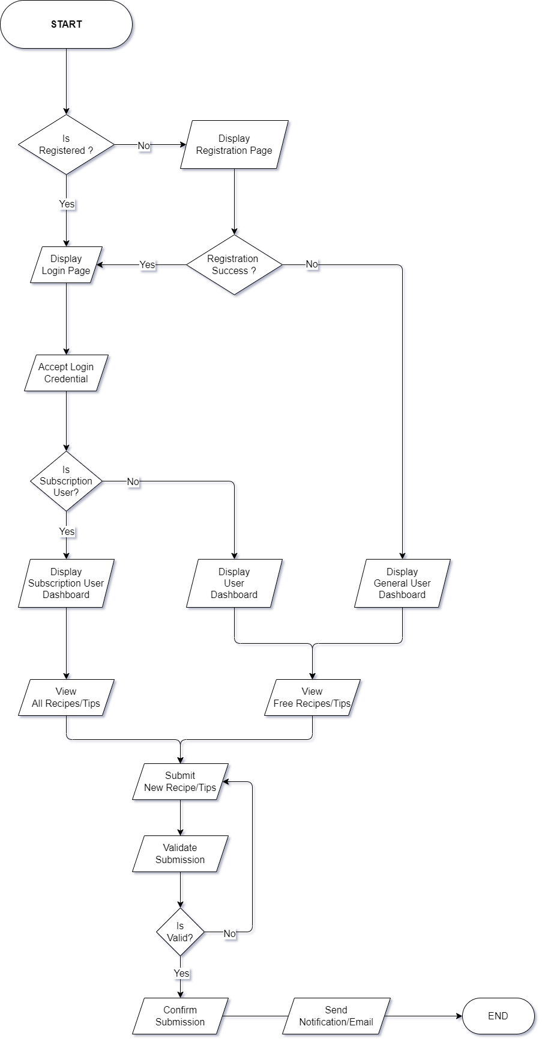

## Displays the flowchart for the Book activity

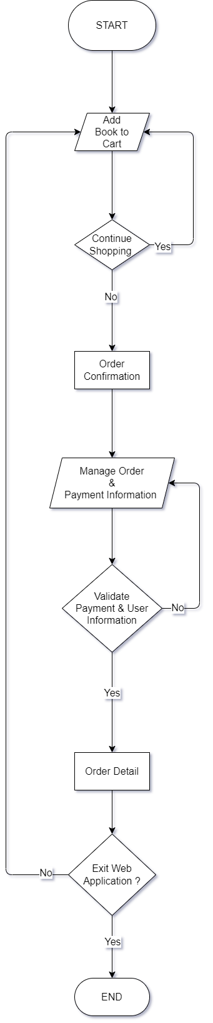

## Displays the flowchart for the Contest activity

## A diagram of a flowchart Description automatically generatedDisplays the flowchart for the Admin activity

|  |  |  |  |  |  |  |
| --- | --- | --- | --- | --- | --- | --- |
| **Project Ref. No.:**  **eP/Advertisement** **Portal Management** **System/01** | | **Activity Plan** **Prepared** **By:** | **Date of Preparation of Activity Plan:** | | | |
| **St.No.** | **Task** | **Actual Start** **Date** | **Actual** **Days** | **Team** **Mate** **Names** | **Status** |
| 1 | Architecture & Design of Project  Algorithms – Data Flowchart  Data Flow Diagram  Entity-Relationship Diagram  Database Design Diagram  Database Structure  Site Map  Task sheet review  Contest Page | Bui Tran Anh Tri | 17/12/2023 | 3 | Bui Tran Anh Tri | Completed |
| 2 | Book Page  Orders & Order Details  Payment  Contact Us/ About Us | 17/12/2023 | 3 | Nguyen Hoang Trung | Completed |
| 3 | Homepage  Categories Recipes & Tips  Recipes & Tips Page  Recipes & Tips:  Index/Search/Filter/Sort/  Create/Update/Delete | 17/12/2023 | 3 | Pham Tien Duc | Completed |
| 4 | User/Login/Role  Membership Subscription  FAQs Page | 17/12/2023 | 3 | Hoang Ngoc Phu | Completed |

# TASK SHEET REVIEW 2

REVIEW 3

# Screen Shots

# Checklist of Validations

# Submission Checklist

# TASKSHEET REVIEW 3